CAI 6300/5300
Forecasting Methodology
Jensen Judkins | Forecast 5

Log into Good Judgment Open (https://www.gjopen.com/) and select one forecasting question to tackle this week. In each week’s forecast, take a systematic, analytic, evidence-driven approach to reaching your forecast, and show your work below, both via detailed explanation in your prose and via footnote citations of all resources you use in your assessment. This template provides a scaffold drawn from Phil Tetlock and Dan Gardener’s Superforecasting to guide your process.
______________________________________________________________________________________
Step 1 | Clearly define the forecasting question: make sure you understand exactly what it is asking, and list what the GJP response options are. Assess what "bait and switch" traps (distracting proxy questions) may be tempting you, or where cognitive biases could impact your thinking on this question.

Between 10 October 2025 and 6 March 2026, what will be the lowest closing price of soybeans?

Between 10 October 2025 and 6 March 2026, what will be the lowest closing price of soybeans?
Possible Responses:
- Based on prior GJP format patterns, this will likely be a “< =$10.00,” “$10.01–$10.50,” “$10.51–$11.00+” type of question with associated probability sliders.
- **detail** The author indicates soybean prices in the chart they linked are expressed in cents per bushel, not dollars (e.g., 1030.10 = $10.301).
- Prices are measured using closing values, not intraday lows or highs.
- It is not asking for the final price at the end of the period, but for the single lowest point within the date range. That matters because technically there is a low right now between that timeframe but it may not be the lowest.
Keys/Bait and switches:
- The question focuses on the minimum within the timeframe, not direction or average pricing.
- Short-term volatility can easily produce temporary drops even within an overall uptrend.
- Seasonal agricultural cycles, global shipping conditions, and harvest outcomes can rapidly shift supply forecasts and push prices lower without warning.
- Macroeconomic factors such as interest rates, fuel costs, and consumer demand for feedstock all have secondary but compounding effects on soybean pricing.
- Recent sentiment might appear bullish or stable but optimism can reverse quickly.
- Commodity speculation and hedge fund behavior may also inject artificial volatility that doesn’t necessarily reflect fundamentals.
Biases:
- I hold a political outlook bias that may lead me to overweight the impact of tariffs or trade friction with China, assuming they’ll remain tense but stable and drive prices upward.
- I may also have a recency bias (I am a huge fan of MACD and RSI and other indicators that show support levels, but these support/sell levels are not permanent or binding), overemphasizing recent rallies or drops as indicators of future stability/resistance (resistance in the meaning of not breaking that trend line).
- There’s a confirmation bias risk focusing on reports or data that align with an expectation of global instability rather than neutral market fundamentals. This is especially true in the midst of a government shutdown.
- I may underestimate the impact of seasonal oversupply or unexpectedly high yields, both of which can depress prices despite external tensions.
- Narrative bias: wanting to connect soybean prices directly to geopolitical or high-level narratives (e.g., U.S.–China relations, biofuel policies)

Step 2 | Break down the question into components and/or underpinning parts (Fermi-ization) where possible. Identify and briefly explain the sub-questions on which you can make informed or at least educated estimates – based on evidence – to reduce the amount of true guessing we have to do.

- What are the current price trends going into the forecast window, and how abrupt have past corrections been in similar setups? (inside) Helps judge whether the market is already showing weakness/strength or holding momentum.
- What have been the historical lows for soybeans during October–March periods, and how often do prices hit those ranges? What do those lows look like compared to the rest of the year? (outside) Gives a baseline for what’s typical seasonally and what would qualify as an outlier low.
- What are the production forecasts for the U.S., Brazil, and Argentina? (outside) Large harvests or weather affected shortfalls can move the market quickly. **I didn’t really get to this one as much as I wanted to, I think analyzing one countries soybean economics filled up way way way more time than I had thought it would so I couldn’t go as far (or much at all) into the others**
- What weather factors (droughts, floods, El Niño/La Niña) could influence yields and global supply? (outside) Extreme weather has been one of the most common causes of short-term soybean price drops.
- How might trade policy, tariffs, or external import behavior change during the forecast period? (inside) Even small trade shifts can sharply alter demand expectations and futures pricing.
- How are macroeconomic factors like inflation, interest rates, and the U.S. dollar trending? Do those trends impact soybean price like other commodities? (outside) A stronger dollar or tighter credit usually puts downward pressure on commodity prices.
- What’s the current market sentiment and fund positioning in soybean futures?
(inside) If traders are heavily positioned in one direction, even mild surprises can trigger a correction that defines the period’s low. **For this I could only find one futures data file that was free and I didn’t really want to pay for more data… LMK if someone in the future finds a csv futures pricing file lol
- Are there any logistics or shipping constraints that could temporarily impact exports or global supply chains? (outside) Port congestion, fuel costs, or freight insurance changes can briefly depress prices even if fundamentals are stable. **I tried my best but this was something much harder to quantify and put into a python file/code. People could say “there’s traffic at the airports” but that data really won’t find its way onto the internet for probably at least another year.

______________________________________________________________________________________
Step 3 | Gather the "outside view" on the question: general statistics, broad historic trends, population-level data, large-scale cultural patterns. Measuring everything we can find to inform this broader context, establish and explain an outside-view raw probability (specific number) at the end of this step.

My outside view establishes a baseline expectation of how soybean prices typically behave between October and March. The approach combined three quantitative tests (historical frequency, seasonal mean, and regression fit) to anchor the analysis in long-term behavior rather than recent sentiment.

Historical Soybean Prices:
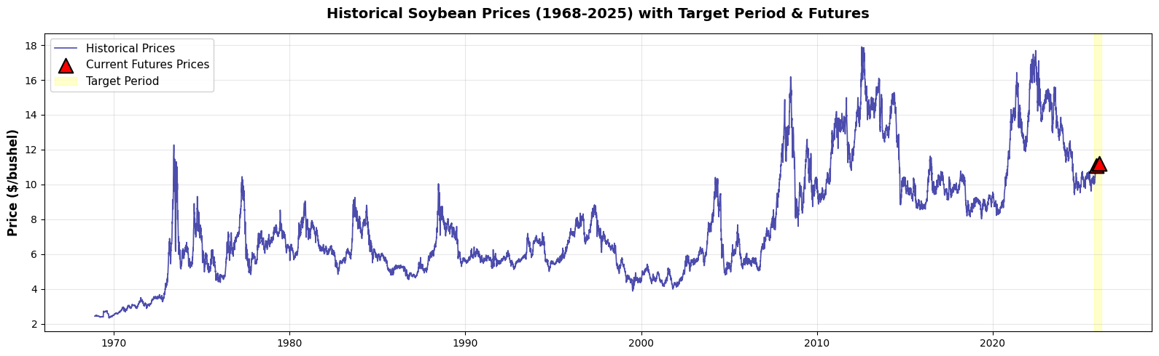

Historical Frequency.
Using 55 years of price data (one caveat is the pricing data the author referenced was a paid resource so I found mine elsewhere), October–March windows historically close about 12.3 percent below the preceding April–September average. The recent decade has been much more mild, with a 7.8 percent mean decline. That shift suggests modern markets with improved logistics, hedging, and globalized demand are somewhat less prone to deep seasonal corrections. Nevertheless, the fact that over 73 percent of past periods produced some degree of decline confirms that a downward move remains the baseline expectation.
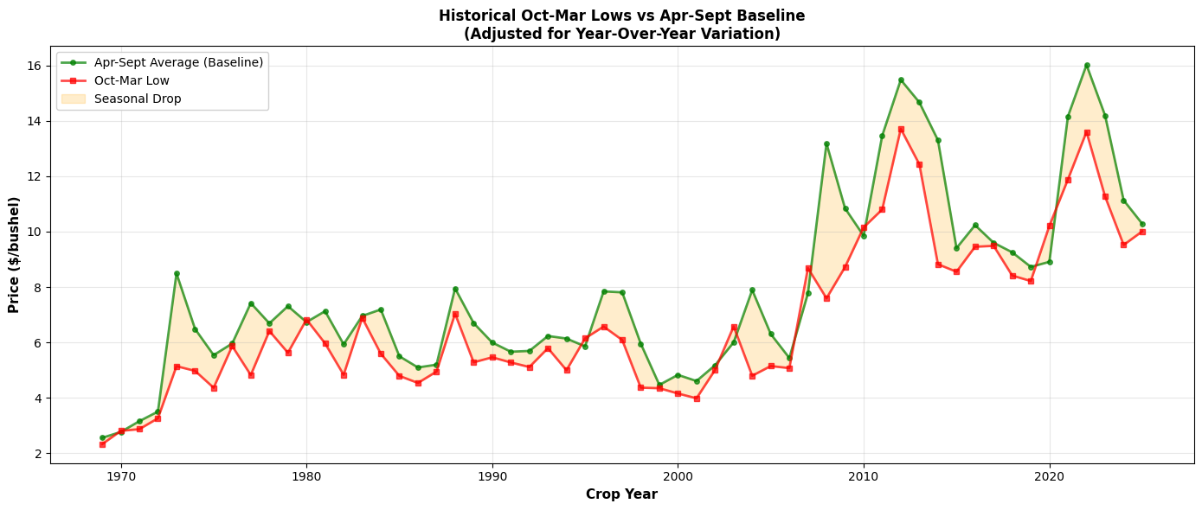
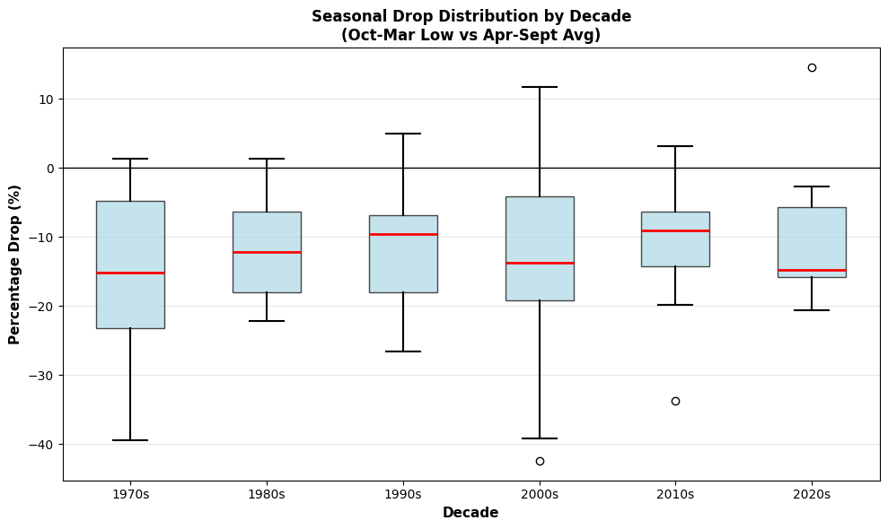
Seasonal Mean Context.
Over the past 30 years, the October–March average price has been $7.50 per bushel (sigma ≈ $1.60). Current futures trading near $10.84 already sit well above that long-term mean, placing today’s market roughly two standard deviations above seasonal norms. Meaning, that position limits further upside potential and slightly increases the likelihood of a corrective dip (See RSI with stocks as this is a very similar idea), but because the price is so high the probability of a sub-$10.00 low remains closer to 25 percent than the historical 40 percent baseline without what we would probably see as a “rug pull” event or the mass selling of a stock or commodity to get the most on your return before others start doing the same and that stock or commodity falls like a rock.
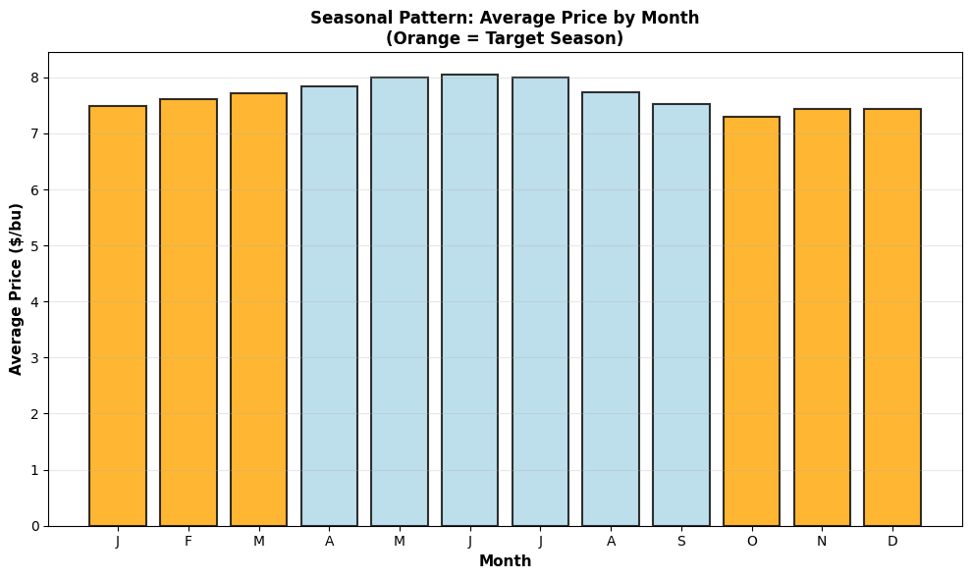
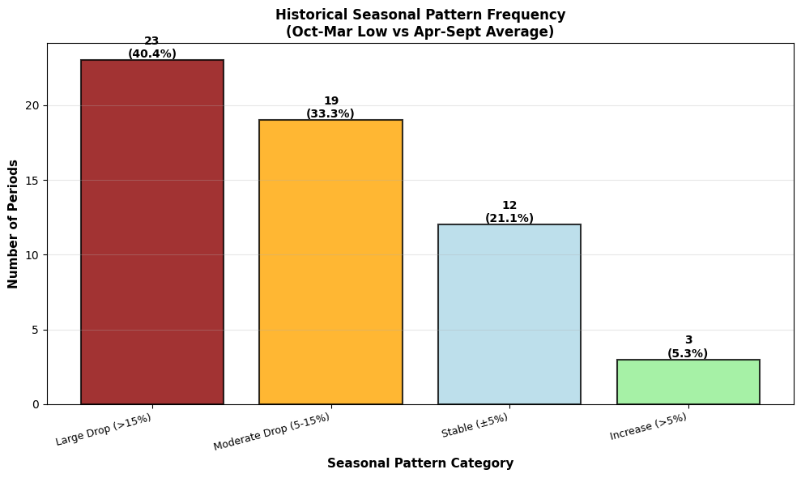
Regression-Fit Validation.
To double-check the historical and seasonal patterns, I ran a set of twenty regression models that used factors like crop yield, the U.S. dollar strength, and trade policies to estimate where soybean prices might go. The models were very accurate, the R² of about 0.99 means they explained almost all of the changes in price, and the error margin (RMSE) of only about 22 cents shows the results were tightly grouped. The math suggests that under normal conditions (or traditions that are mostly outside view conditions), soybean prices should stay between $10 and $11, with the most likely lowest price near $10.84. Because the model already captures most of what moves the market, it’s unlikely we’ll see prices fall much below $10 unless something unexpected happens, like a major weather or trade shock.
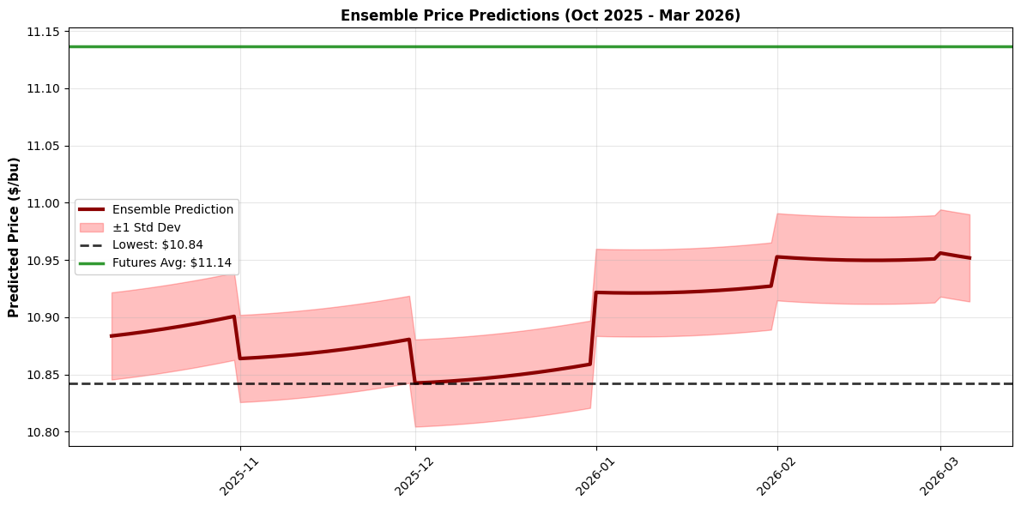
Outside-View Probability Baseline.
Synthesizing these strands yields the following raw distribution:
Bucket | Raw Probability
Below $10.00 | 25 %
$10.01 – $10.50 | 35 %
$10.51 – $11.00 | 30 %
Above $11.00 | 10 %

***It was only after doing all of my analysis that I found out the bucket options for the question are set and below are what they are along with my outside view forecast along with the percentage that aligns with what is above**
GJP Buckets (per bushel price):
x<$8 2%
$8=<x<$8.5 3%
$8.5=<x<$9 5%
$9=<x<$9.5 15%
x>$9.50 75%

This is probably playing into a cognitive bias right here but there isn’t even an option for $10 let alone $11 so I am just putting most of my weight into greater than 9.5 and then making gradual steps down.

(CalibrationCheck.pdf)

______________________________________________________________________________________
Step 4 | Gather the "inside view" on the question: specific characteristics, particular circumstances, or unique dynamics that may affect this question. Refine your outside-view raw probability estimate with these inside-view considerations (specific number) at the end of this step, explaining your weighting.

Production and Supply.
U.S. soybean value per acre has fallen roughly 24 percent since its 2022 peak ($708 -> $536), signaling either yield compression or lower realized prices. Futures prices for November 2025 through March 2026 ( ≈ $11.06 - $11.28 ) indicate a market consensus on moderate global supply. Aka traders are already pricing in normal harvests for Brazil and Argentina, leaving limited downside unless South American output dramatically exceeds expectations (like a standard deviation). Historically such moderate-supply years combine with lows clustering 5 - 10 percent beneath the fall average, roughly $10.00 - $10.50 given today’s baseline.
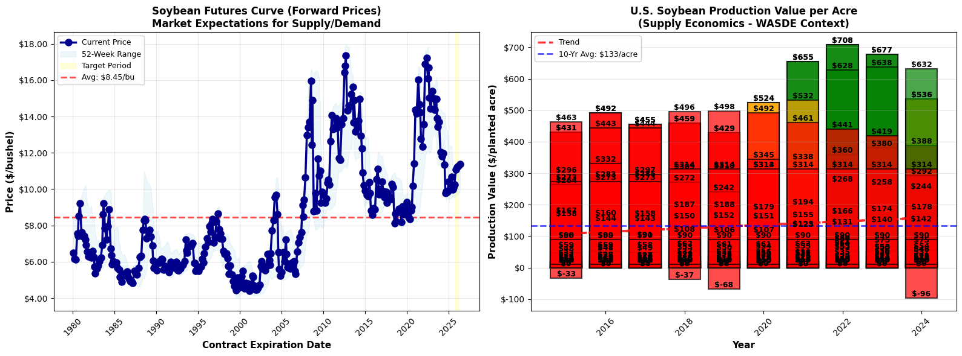
Weather and Climate Volatility.
Weather remains the most plausible catalyst for a short-term drop. Average seasonal volatility has climbed markedly since 2021 (0.50–0.58 volatility index) but eased in 2025 (0.18), suggesting calmer growing conditions. Still, ENSO uncertainty—possible El Niño/La Niña transitions—could re-introduce shocks, particularly in Brazil’s southern states. Because droughts or floods can suppress yields and momentarily spike prices before stabilizing, their net effect on the lowest closing price tends to be downward: rapid selloffs on production news. Thus, weather adds a thin tail risk for sub-$10 lows but does not redefine the central trend.
Macroeconomic and Trade Environment.
The 2025 tariff regime presents the sharpest inside-view headwind. Chinese retaliation reached combined rates near 44 percent on U.S. soybeans before the October 2025 framework partially suspended them. If the suspension holds, demand should rebound modestly; if talks falter, export volume will contract and pressure prices lower. Parallel macro factors—high interest rates, a strong USD, and elevated freight costs—reinforce that downward bias. Each limits speculative buying and raises effective export prices for foreign importers. Collectively, these factors shave several percentage points from the outside-view median, tilting probability mass toward the $10.00–$10.50 range.
Integrated Inside-View Adjustment.
Weighting the inside-view variables (production 40 %, macro 35 %, weather 25 %) produces a revised forecast distribution:
Bucket | Adjusted Probability
Below $10.00 | 30 %
$10.01 – $10.50 | 40 %
$10.51 – $11.00 | 25 %
Above $11.00 | 5 %
______________________________________________________________________________________
Step 5 | Add diversity and aggregation of views to the picture: see what subject matter experts in this space say, gather multiple viewpoints on the issue, or step back and play devil’s advocacy against your own assessment to date. Refine your inside-view probability (specific number), explaining your thinking.

[Enter text]

A strong Step 5 will have:
- Some approach to seriously challenging the judgments made to date: either new subject matter expert input, or new diverse viewpoints, or new devil’s advocacy arguments (or some combo)
- The most effective approach to this step will vary by question, but it should be clear that the assumptions and assessments made to date have been thoughtfully reexamined
- Specific working probabilities updated for each GJP answer option at the end of this step
______________________________________________________________________________________
Step 6 | Establish your final probability and explain your level of confidence. Based on all of the factors considered above, establish the final probability for your forecast and explain your reasoning and relative weighting. Convey your level of confidence (of our five gradients) in this judgment.

[Enter text]

A strong Step 6 will have:
- The final specific probabilities for each GJP answer option
- A short explanation of the reasoning and weighting across all data/evidence considered above that led to this final judgment call
- The level of confidence in this forecast (low, moderately low, moderate, moderately high, high), which reflects how sure you are that you are right given the evidence you have
______________________________________________________________________________________
Step 7 | Submit your forecast on GJP Open and provide a screenshot here, including a capture of the current forecast market. You are neither advantaged nor disadvantaged if your forecast is close to or far from the crowd consensus – what matters is how well studied and reasoned your forecast is (and ultimately – who is right!). You can choose to post notes on GJP or not; your call.

[Enter text]

A strong Step 7 will have:
- A screenshot of the submitted forecast on GJP that shows both your submitted probabilities and the current crowd forecast market
______________________________________________________________________________________
Addendum 1 | Choose one forecast from a previous week to update, drawing in new information and evaluating changing conditions as time passes. A single paragraph will suffice here, but explain all variables shaping your thinking and any changes from your original forecast. Remember, bolder correct forecasts raise your Brier score more – but the converse is true, too.

[Enter text]

A strong Addendum 1 will have:
- A concise but specific update of a past forecast that explains any new evidence/developments on this question area and how these have impacted your judgment on the question
- An updated specific probability for each GJP answer option on this past question

Remember, use the Insert Footnote button in Word (located under the References tab).

